Basic Statistics Overview

# Part 1: Using SPSS

1. Open SPSS:
   1. Windows: Start > All programs > IBM (usually) > SPSS XX (18-19 currently).
   2. Mac: Finder > Applications > SPSSinc > SPSS
   3. Note: Some older versions (16-18) are called PASW

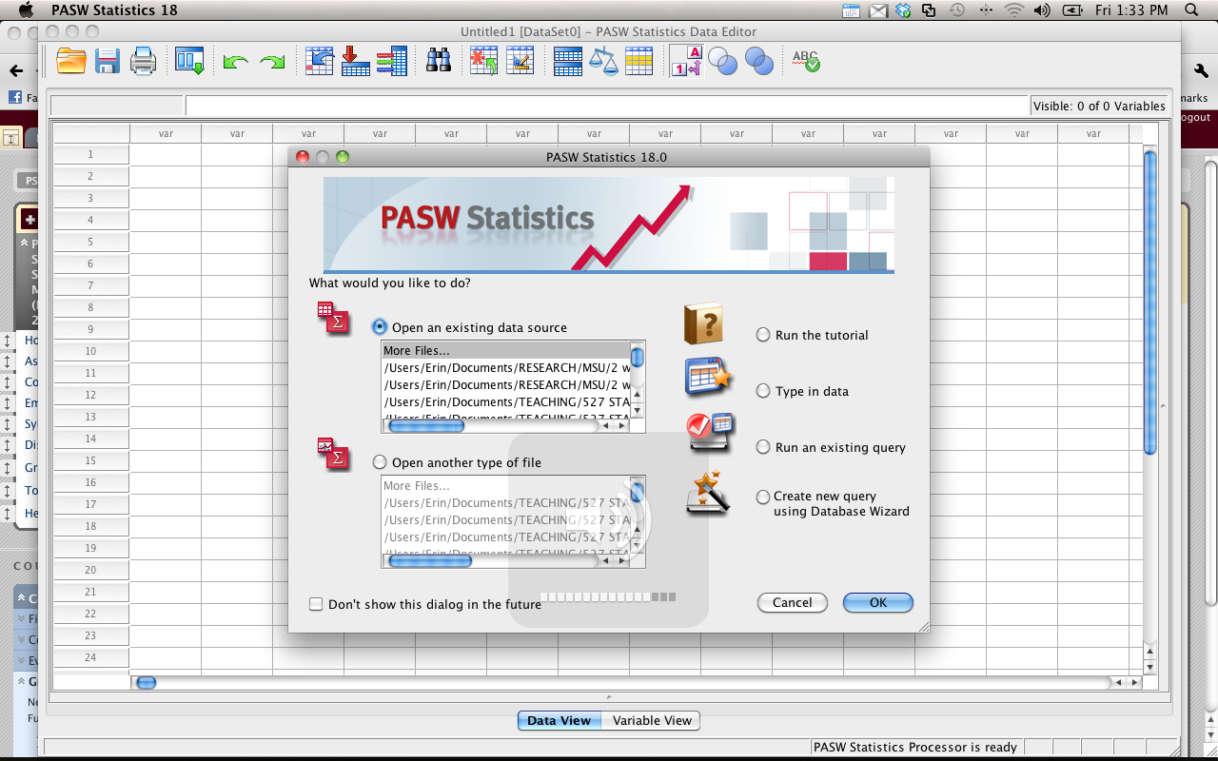

*Note.* Demos are from SPSS Mac Version 18 – the options and drop down boxes are the same as Windows versions.

1. Opening files
   1. File > Open > Data
   2. .sav files are data files.
   3. .sps files are syntax files.
   4. .spo are output files.

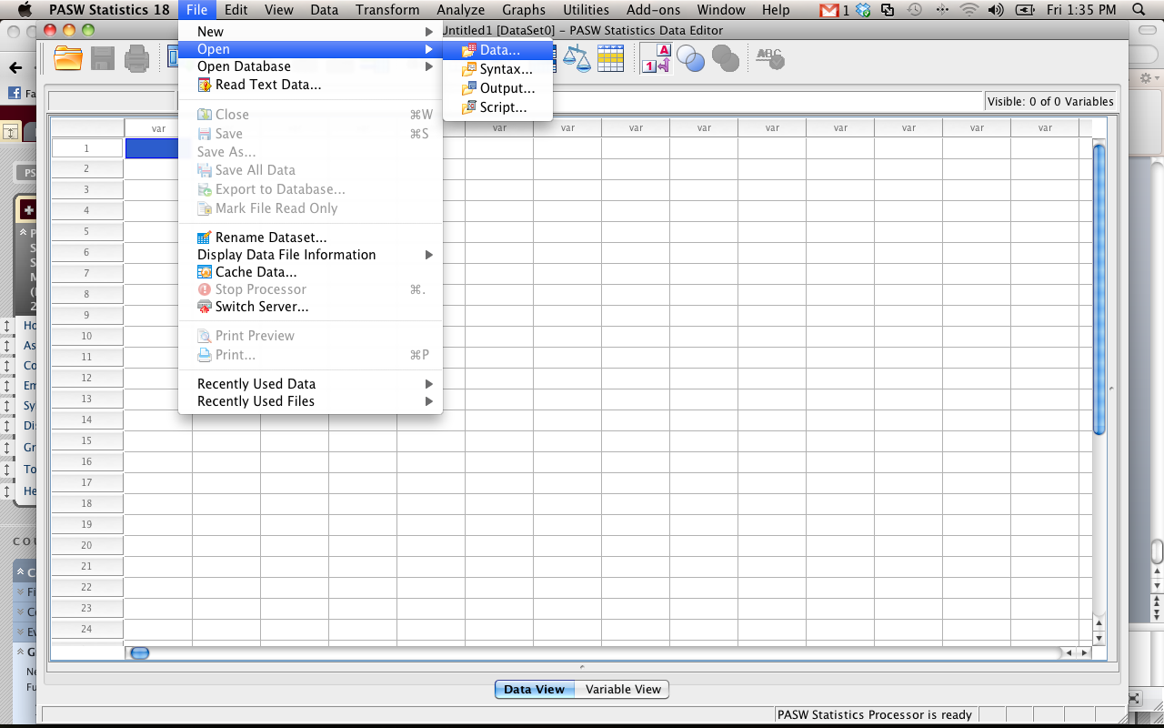

1. File set up: two ways to view the data:
   1. Data view:
      1. Columns = variables
      2. Rows = people – each person gets their own row
      3. Behavior example
         1. Gives you the place for a behavior (column 1)
         2. And then the ratings for each type of behavior (going across).
      4. Looks a lot like excel (except that you can label the variables at the top instead of in the first row)

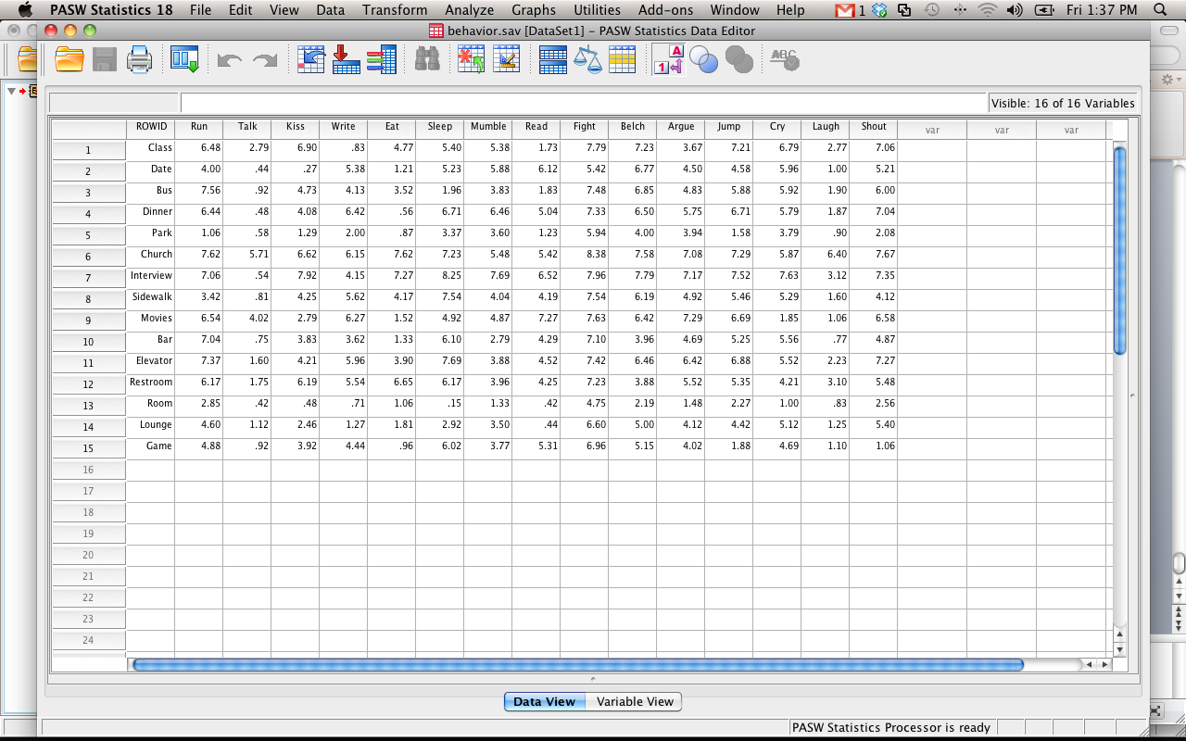

* 1. Variable view:
     1. Has the list of variables (one for each row)
     2. These will be the columns across the top
     3. Type column
        1. If you want to put letters into a column, be sure the type column is “string” or it won’t work.
        2. Also! If you label a column as string and then try to use it in analyses, it will tell you politely that you are dumb.

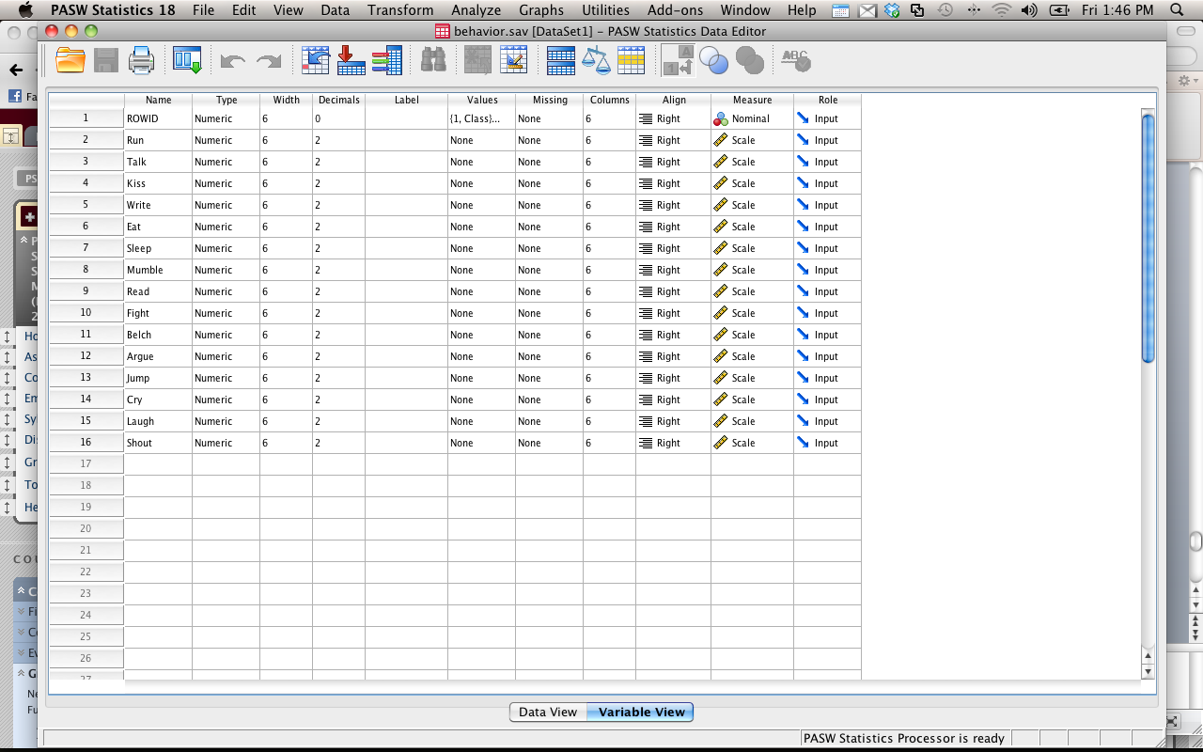

* + 1. Values column
       1. Click on the little box next to values for the rowid variable.
       2. Now you’ll see a bunch of numbers with corresponding strings
       3. This is a way to label your groups
    2. If you can’t see the values you’ve given something when looking at data view
       1. View > value labels

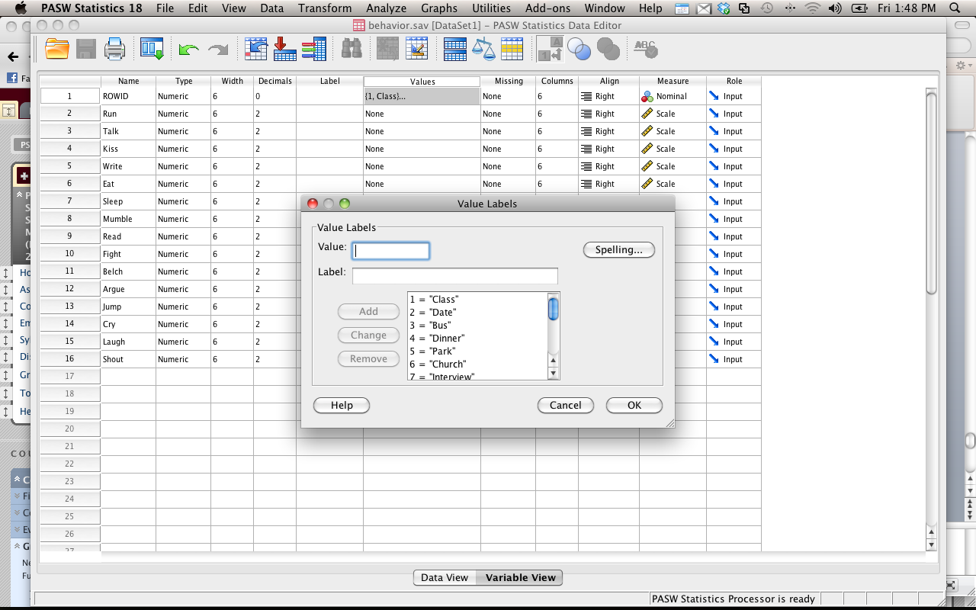

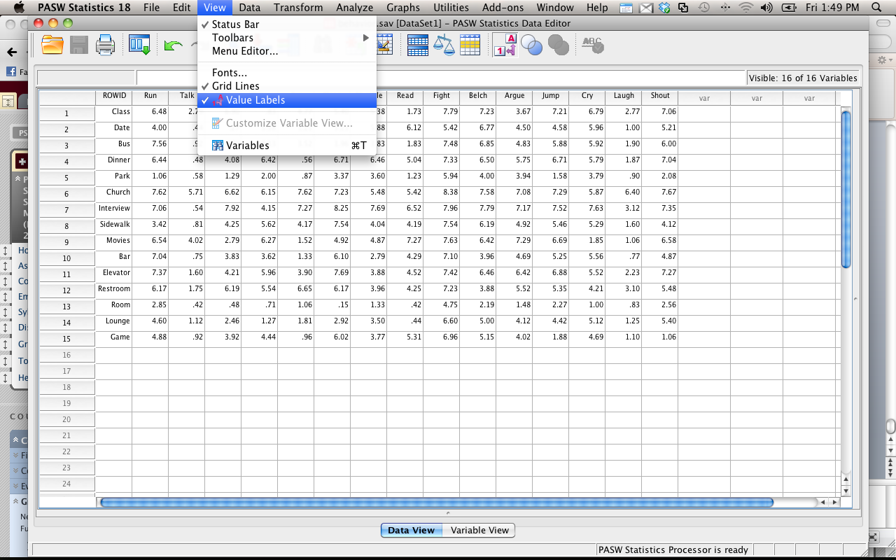

* 1. If you want a new variable, you can just start typing in a new column (in either data or variable view).
     1. It will label the variable for you as “var0001” or something similar.
     2. If you want to give it a name, click variable view, and you can relabel it.
  2. If you want to add new people
     1. Just start typing in data in a new row.
     2. Note: if you have a column with value labels, then you’ll need to stick with the same numbering system
     3. If you give it a number it doesn’t recognize, it’ll show up as that number.

1. Data Drop Down
   1. The data option lets you find data you need quickly, or sort cases
   2. We are going to use sort cases
   3. Split file – let’s you run an analysis separate for each group (helpful for data screening).
   4. Select cases – let’s you pick only a subset of the data

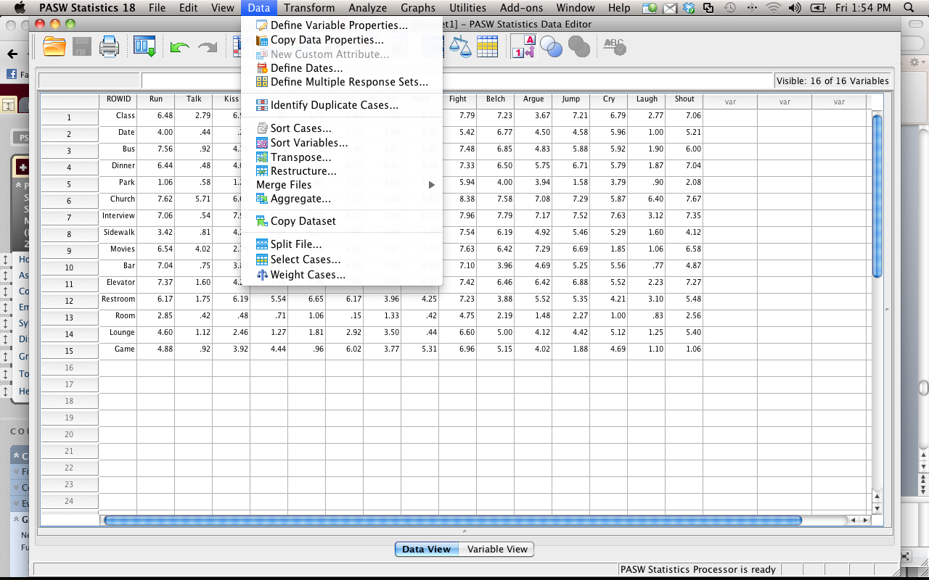

1. Transform Drop Down
   1. Transform lets you change variables without having to start over
   2. You can create new variables that are functions of old variables (i.e. average two columns, add up four columns, create an interaction term).
   3. Most commonly we are going to use compute variable.

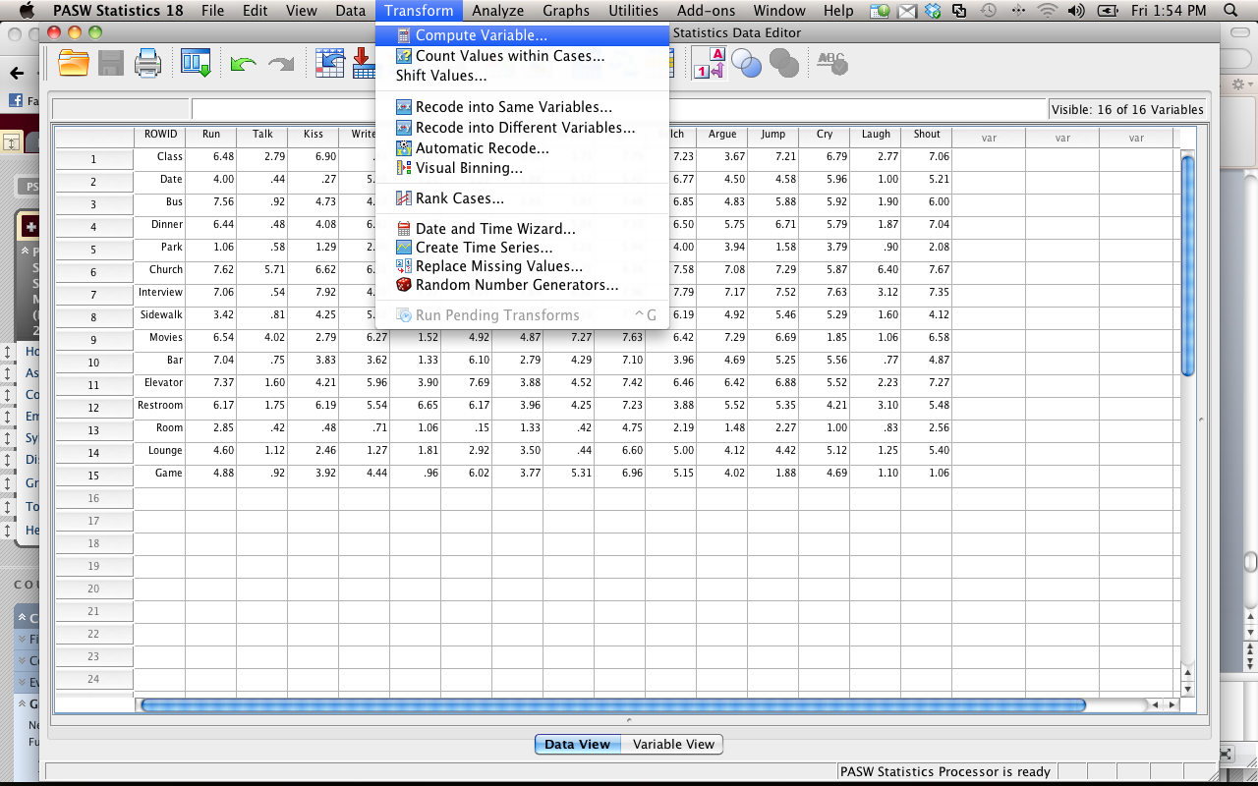

1. Analyze Drop Down
   1. Most common options we will use
   2. (go through how to run each test when we cover that test).
   3. If you are running a statistical test, it will be under Analyze.

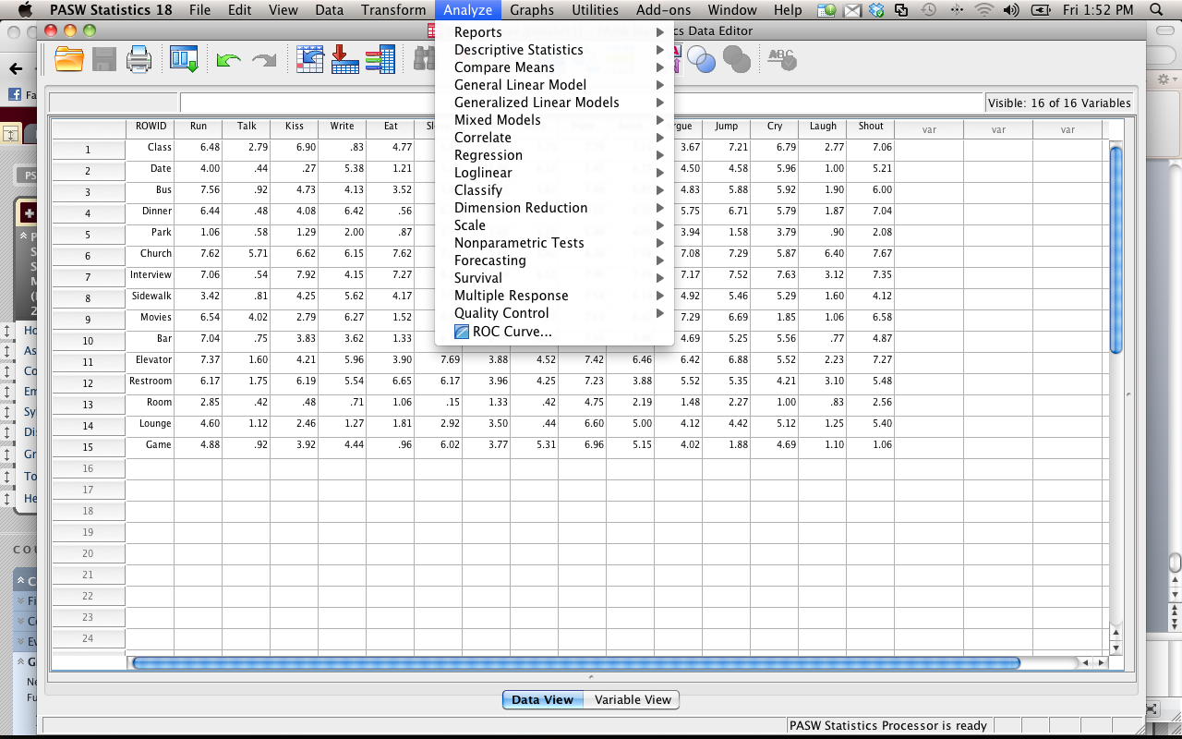

1. Let’s you create scatter plots, histograms, line, and bar graphs.
   1. Note: most people (myself included) find excel a little easier to use than SPSS when it comes to graphs.
   2. Either is acceptable.

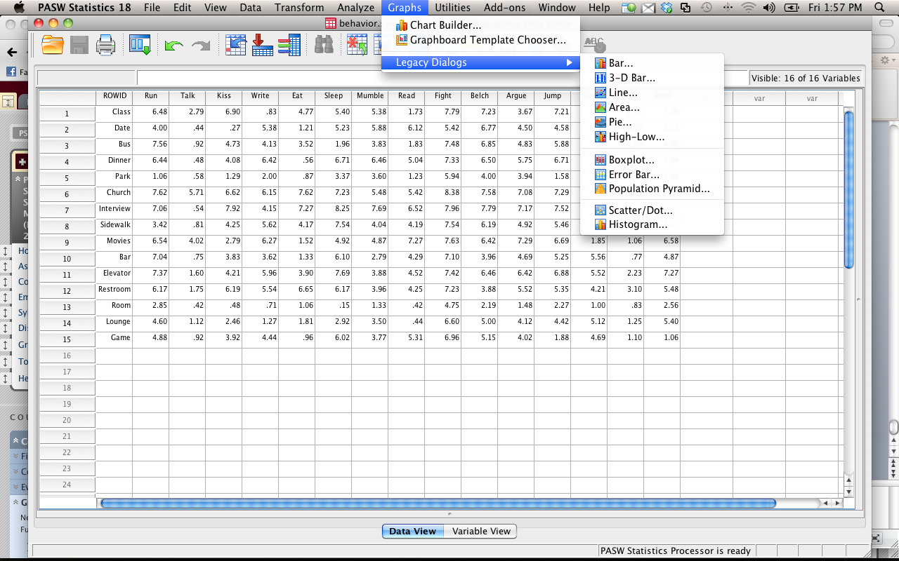

1. Entering data
   1. Each person should get their own row.
      1. For dependent data, or when you took several variables from the same person, each person will have several columns of data.
   2. Each variable should get it’s own column.
   3. You have to enter group information into its own column – make up labels for them but they *need* to be numbers (1, 2, 875, doesn’t matter).
   4. You can use value labels to give them names (see above).

# Part 2: Introductory Statistics

1. Types of Statistics:
   1. Descriptive Statistics: create a picture of the data – describe
      1. Mean – average of all scores
      2. Mode – score that appears the most often
      3. Median – score that appears in the middle when arranged in order
      4. Variance – average distance of scores from the mean
      5. Standard deviation – standardized variance (or standard average distance from the mean)
   2. Inferential statistics
      1. Infer information about the data.
      2. Tells you if your data is different from some known sample OR some other data set.
      3. Hypothesis testing
   3. Parametric versus non-parametric
      1. Parametric – used on interval and ratio data, numbers that are continuous in nature
         1. Requires more assumptions
      2. Non-parametric – used on all data types (especially nominal, categorical)
         1. Does not require same assumptions
2. Descriptives How-To:
   1. Analyze > Frequencies
   2. Analyze > Descriptives

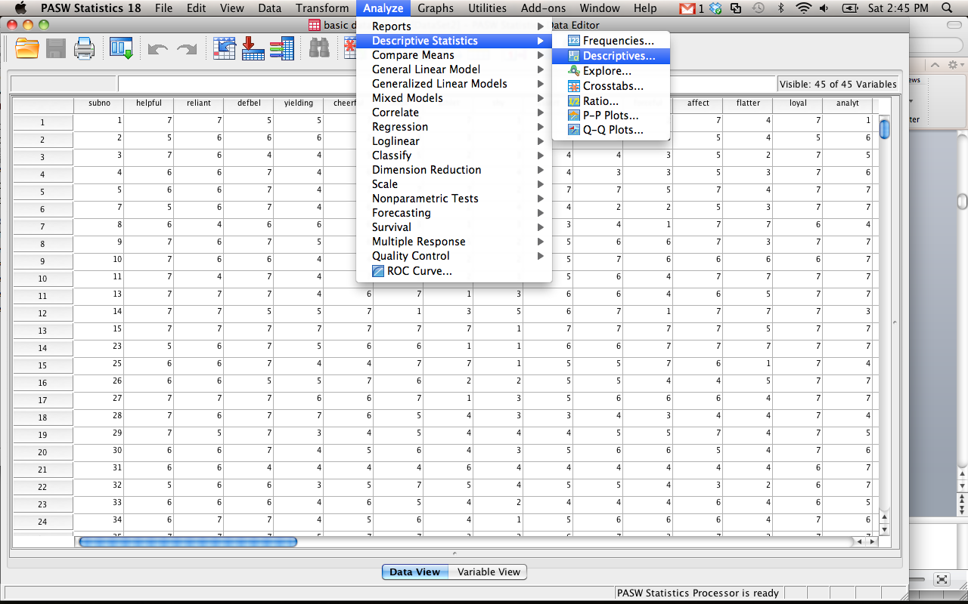

* 1. Frequencies:
     1. Move over the variables you want to get descriptive information from.
     2. Hit the Statistics button on the right side.

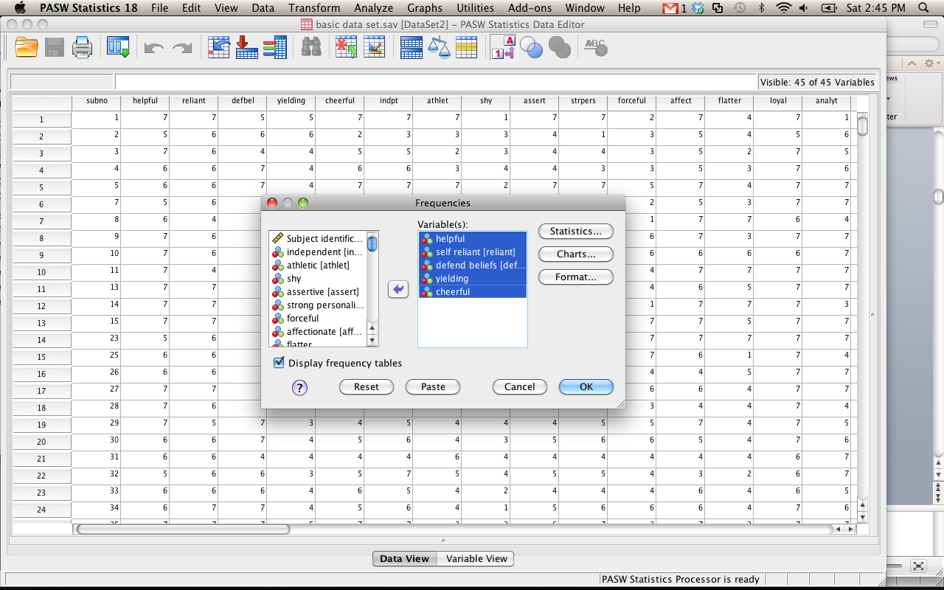

* + 1. Select the options you want (mean, mode, standard deviation, etc.)

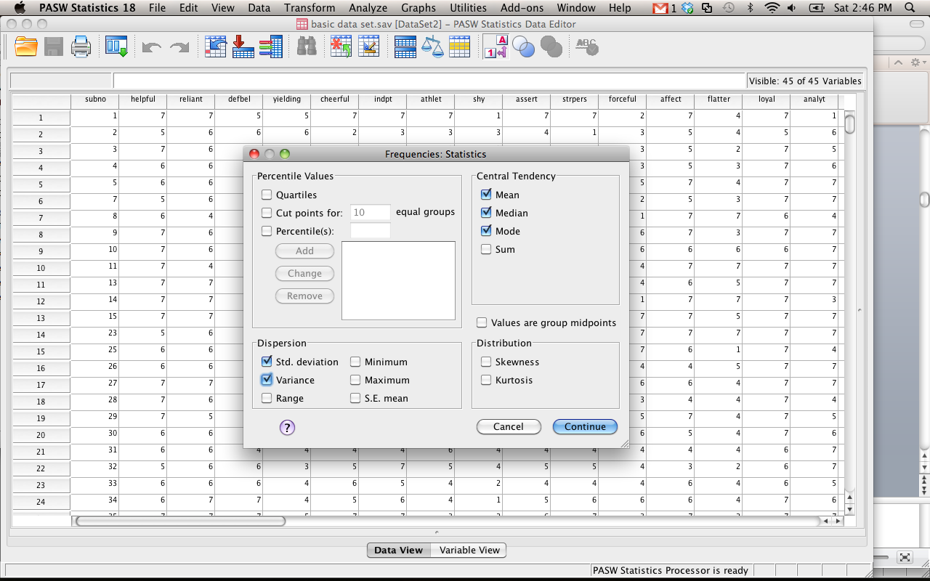

* + 1. Hit continue. You will be back at the options for frequencies.
    2. Hit the charts button.
       1. You will be able to select Histograms (you will use this information a lot). I usually also select view normal curve – it helps you see how skewed the data can be.

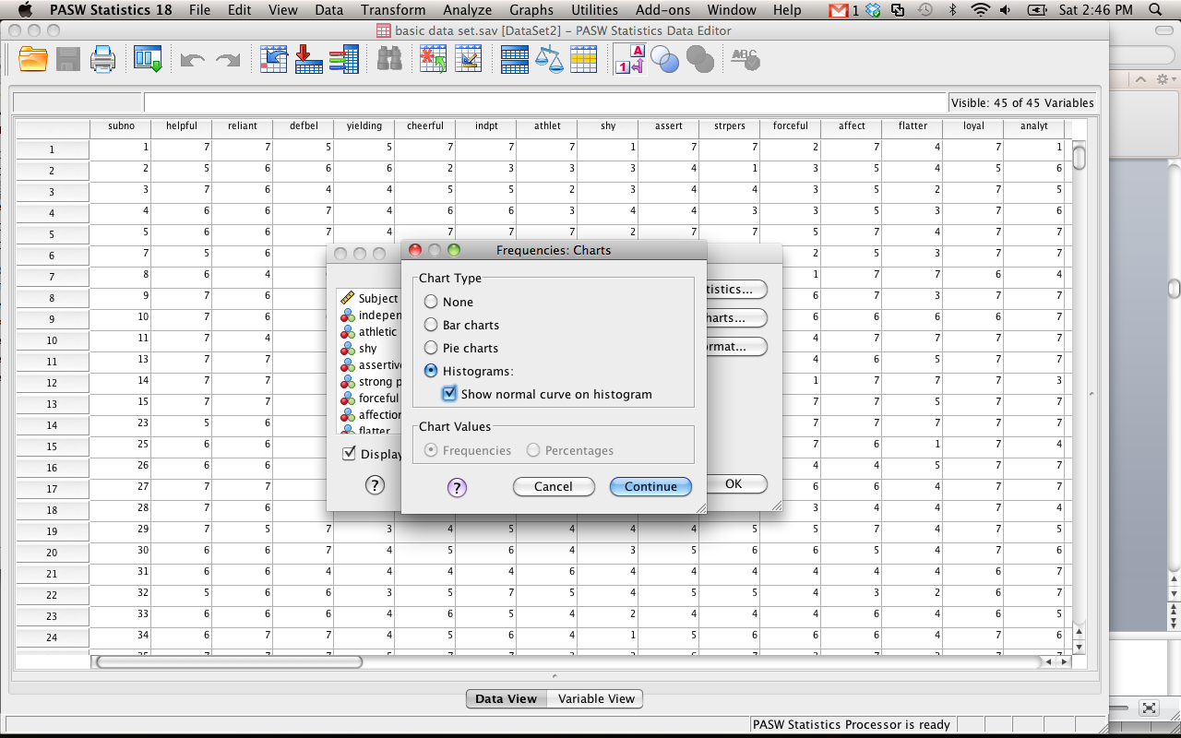

* 1. Frequency Output example:

| **Statistics** | | | | | | |
| --- | --- | --- | --- | --- | --- | --- |
|  | | helpful | self reliant | defend beliefs | yielding | cheerful |
| N | Valid | 369 | 369 | 369 | 369 | 369 |
| Missing | 0 | 0 | 0 | 0 | 0 |
| Mean | | 6.05 | 5.93 | 5.91 | 4.53 | 5.81 |
| Median | | 6.00 | 6.00 | 6.00 | 4.00 | 6.00 |
| Mode | | 7 | 6 | 7 | 4 | 6 |
| Std. Deviation | | .999 | 1.212 | 1.339 | 1.327 | 1.066 |
| Variance | | .998 | 1.468 | 1.793 | 1.761 | 1.136 |

| **helpful** | | | | | |
| --- | --- | --- | --- | --- | --- |
|  | | Frequency | Percent | Valid Percent | Cumulative Percent |
| Valid | 1 | 1 | .3 | .3 | .3 |
| 3 | 6 | 1.6 | 1.6 | 1.9 |
| 4 | 19 | 5.1 | 5.1 | 7.0 |
| 5 | 67 | 18.2 | 18.2 | 25.2 |
| 6 | 130 | 35.2 | 35.2 | 60.4 |
| 7 | 146 | 39.6 | 39.6 | 100.0 |
| Total | 369 | 100.0 | 100.0 |  |

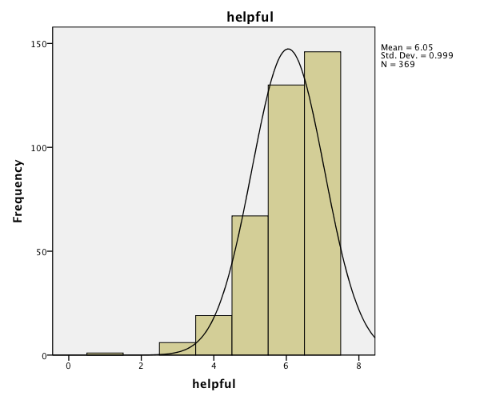

* + 1. First box gives you: Mean, median, mode, variance, standard deviation
    2. Next set of boxes are frequency tables - List all the scores and how many of them fall into those scores
    3. On this output, we also asked for histograms – whew look at the skew!
  1. Descriptives
     1. If you do analyze > descriptives you have less options for output, but it is quicker because it’s sort of pre-set to the normal things people want.
     2. Again, move over the variables you want to get descriptives from.

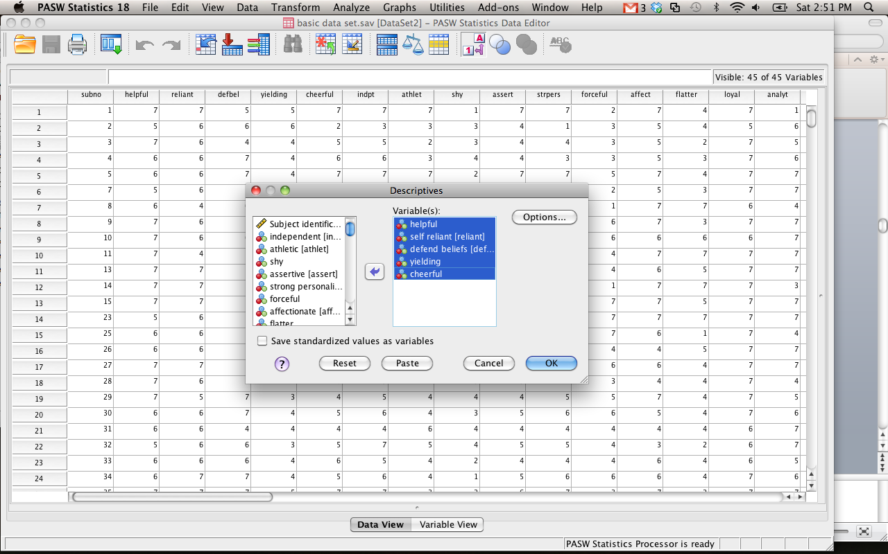

* + 1. Hit options to get different types of descriptives.
    2. Pick your favorite, hit continue and ok.

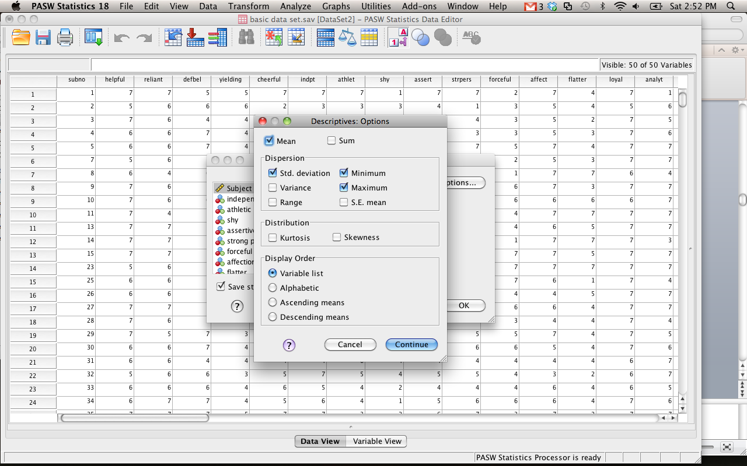

* 1. Descriptives output:
     1. Will only give you:
        1. Mean, standard deviation, variance (if you ask), min and max
        2. SE = standard error of mean or standard deviation of the distribution of samples
     2. Does not do median, mode
     3. Will give you standardized scores (z-scores)

| **Descriptive Statistics** | | | | | |
| --- | --- | --- | --- | --- | --- |
|  | N | Minimum | Maximum | Mean | Std. Deviation |
| helpful | 369 | 1 | 7 | 6.05 | .999 |
| self reliant | 369 | 1 | 9 | 5.93 | 1.212 |
| defend beliefs | 369 | 1 | 7 | 5.91 | 1.339 |
| yielding | 369 | 1 | 9 | 4.53 | 1.327 |
| cheerful | 369 | 1 | 9 | 5.81 | 1.066 |
| Valid N (listwise) | 369 |  |  |  |  |

1. Hypothesis Testing
   1. Basic gist: You are pitting two rival answers against each other. Think of it like your favorite sport. You have a Favorite team (Research hypothesis) versus your enemy team (Null hypothesis). You want them to be different. You want your team to win (reject the null!).
   2. Terms:
      1. Null hypothesis – all groups are equal, the IV and the DV are not related
      2. Research hypothesis – groups are not equal, one mean > another mean, IV and DV are related
      3. Rejecting the null / statistically significant – when your team wins! You find that the probability of the null hypothesis is very low, so you reject the idea that everything is equal (or that your team would never win).
      4. Retaining the null / not statistically significant – the probability of the null hypothesis is not low enough, it could be that the groups are equal, or that your team might not win.
      5. P-values – the probability of getting that results (t-value, f-value, chi-square, etc.) if the NULL were true
         1. You want your team to win! So you want the null to be false. Therefore, you want the probability of being wrong to be very low.
      6. One tail test – you only want one direction (higher or lower) – note that a lot of multivariate statistics will not let you make this assumption.
      7. Two tail test – you are not sure if it is higher or lower, so you hedge your bets and look for both of them.
      8. Assumptions: Things that must be true for your test to return an answer that is reasonably correct
         1. GIGO – if you feed garbage data into SPSS, then you will get a garbage answer out.
         2. Therefore, when the assumptions are not met, you do not know what the answer you got actually *means.*
   3. Cut off Scores:
      1. Usually you learn about cut off scores and the score has to be greater than the cut off score to be significant
      2. You are finding the point in which the probability of that score is less than 5% or 1%.
      3. Now we are going to use the SIG column or the precise p-value (it’s much easier!).
         1. SPSS will give you the p-value. You want your p-values to be less than .05 or .01.
      4. Eliminates the need for cut off scores (*sort of*)
         1. Not for z-tests
         2. Not for post hoc tests
         3. Not for one tailed tests
         4. Always uses a two-tailed test (if applicable).
2. Univariate versus Multivariate
   1. Univariate – 1+ IVs to 1 DV
      1. Most common used
      2. Limit you to only one DV
      3. Types
         1. Z
         2. *T-tests*
         3. *AN©OVA\*\**
         4. *Correlation*
         5. *Regression\*\**
         6. *Chi-Square*
   2. Multivariate – 1+ IVs to 1+ DVs
      1. Types
         1. *MANOVA/MANCOVA*
         2. *Profile Analysis (repeated measures)*
         3. *Multiple Regression*
         4. *Discriminant Analysis*
         5. *Log Regression*
         6. *Factor Analysis*
         7. *Canonical Correlations*
         8. *Frequency Analysis*
         9. *And many more…*
3. Z Walk Through
   1. Z-Score
      1. When: one person, population mean, and population standard deviation are know
      2. Assumptions: Normal Distribution
      3. Formula: (X – M) / SD
         1. Person’s score – average score divided by the standard deviation
      4. Example: A personnel psychologist has to decide which of three employees to place in a particular job that requires a high level of coordination. All three employees have taken tests of coordination, but each took a different test. Employee A scored 15 on a test with a mean of 10 and a standard deviation of 2; Employee B scored 350 on a test with a mean of 300 and a standard deviation of 40; and Employee C scored 108 on a test with a mean of 100 and a standard deviation of 16. (On all three tests, higher scores mean greater coordination.)
      5. Who’s the best?

* 1. Z-Tests:
     1. When: one group of people, population mean, population standard deviation are known
     2. Assumptions: Normal distribution
     3. Formula: (M – u) / o
        1. Sample mean – population mean divided by population standard deviation
     4. Example: In a study to see if children from lower socio-economic status (SES) neighborhoods have lower than average test-taking skills, a psychologist administered a standard measure of test-taking skills to a set of randomly chosen children from a low SES neighborhood and found them to have a score of 38. The average score on this measure for the population in general is 50 with a standard deviation of 10. Using the .05 level of significance, what conclusions should be drawn about whether children from low SES neighborhoods have lower test-taking ability?

1. T-Tests
   1. Types
      1. Single sample
      2. Dependent
      3. Independent
   2. Assumptions:
      1. Normal Curves
      2. Homogeneity – equal variances for each group
   3. Single sample example
      1. Uses: when you have one group of people to compare to a population mean.
      2. A school has a gifted/honors program that they claim is significantly better than others in the country. The national average for gifted programs is a SAT score of 1250.
      3. Use the file single sample t-test here.
      4. Analyze > Compare means > one-sample t-test

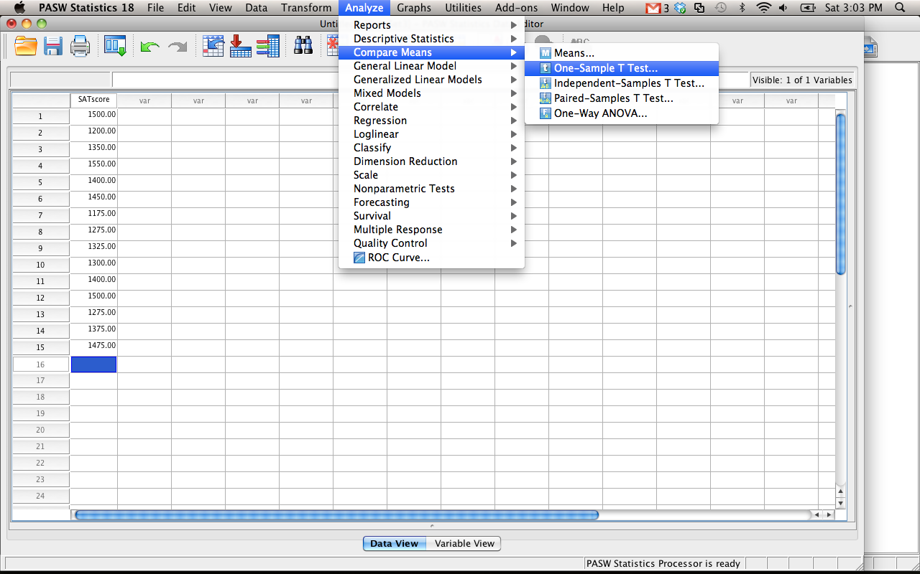

* + 1. Move over the variable you want to test.
    2. Be sure to enter your population mean in the test-value spot and hit ok.

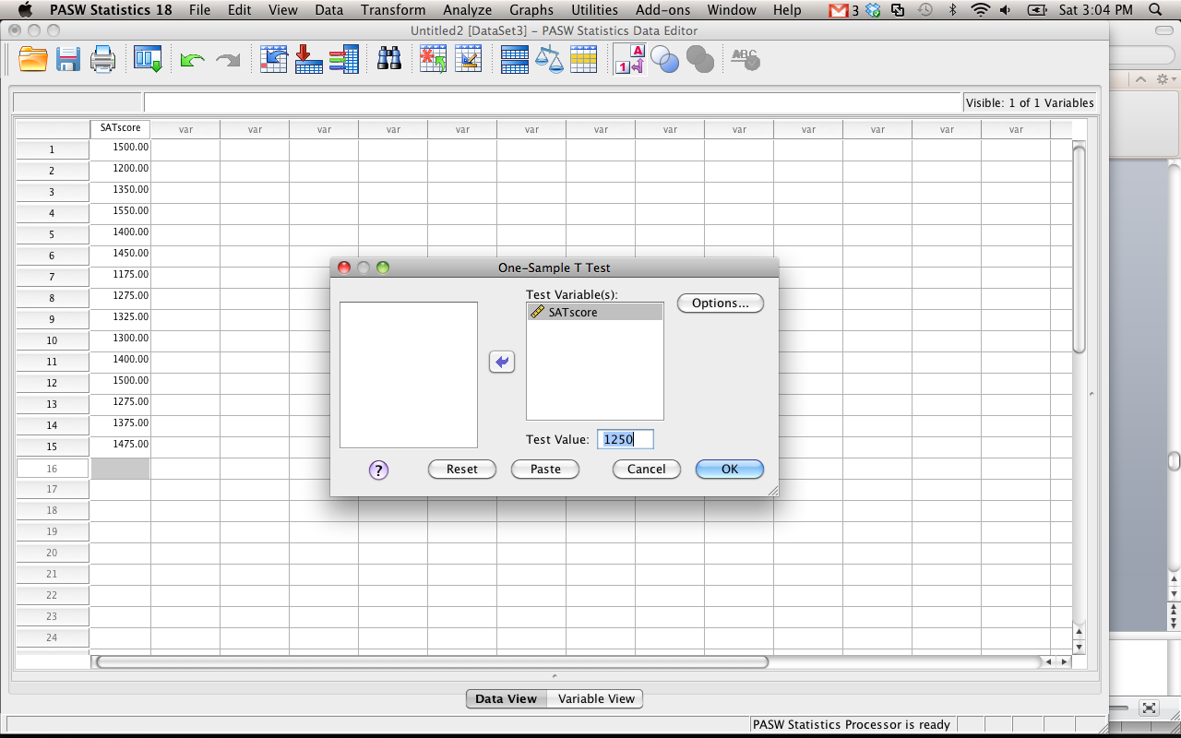

* + 1. Output example:

| **One-Sample Statistics** | | | | |
| --- | --- | --- | --- | --- |
|  | N | Mean | Std. Deviation | Std. Error Mean |
| SATscore | 15 | 1370.0000 | 112.67843 | 29.09345 |

| **One-Sample Test** | | | | | | |
| --- | --- | --- | --- | --- | --- | --- |
|  | Test Value = 1250 | | | | | |
| t | df | Sig. (2-tailed) | Mean Difference | 95% Confidence Interval of the Difference | |
| Lower | Upper |
| SATscore | 4.125 | 14 | .001 | 120.00000 | 57.6008 | 182.3992 |

* + - 1. N = number of people
      2. Mean = group mean
      3. SD = standard deviation of group
      4. SE = standard error.
      5. One sample box: t – found t-value
      6. Df = degrees of freedom
      7. Sig = p-value (want this to be less than .05)
      8. Write up example:
         1. *t*(14) = 4.125, *p* = .001
  1. Dependent t-test
     1. Use: when you have one group of people tested twice, before/after scores, etc.
     2. Example: In a study to test the effects of science fiction movies on people's belief in the supernatural, seven people completed a measure of belief in the supernatural before and after watching a popular science fiction movie. Participants' scores are listed below with high scores indicating high levels of belief. Carry out a t test for dependent means to test the experimenter's assumption that the participants would be less likely to believe in the supernatural after watching the movie.
     3. Use dependent t example here.
     4. Analyze > compare means > paired samples t-test
     5. Move over the variables you wish to test into variable 1 and variable 2. You can test lots of combinations at once.
     6. Output:

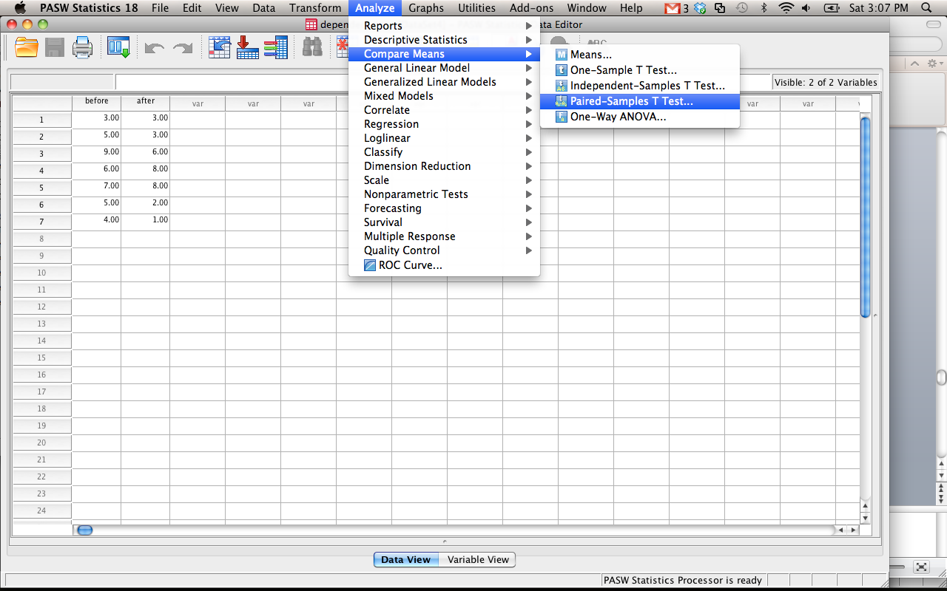

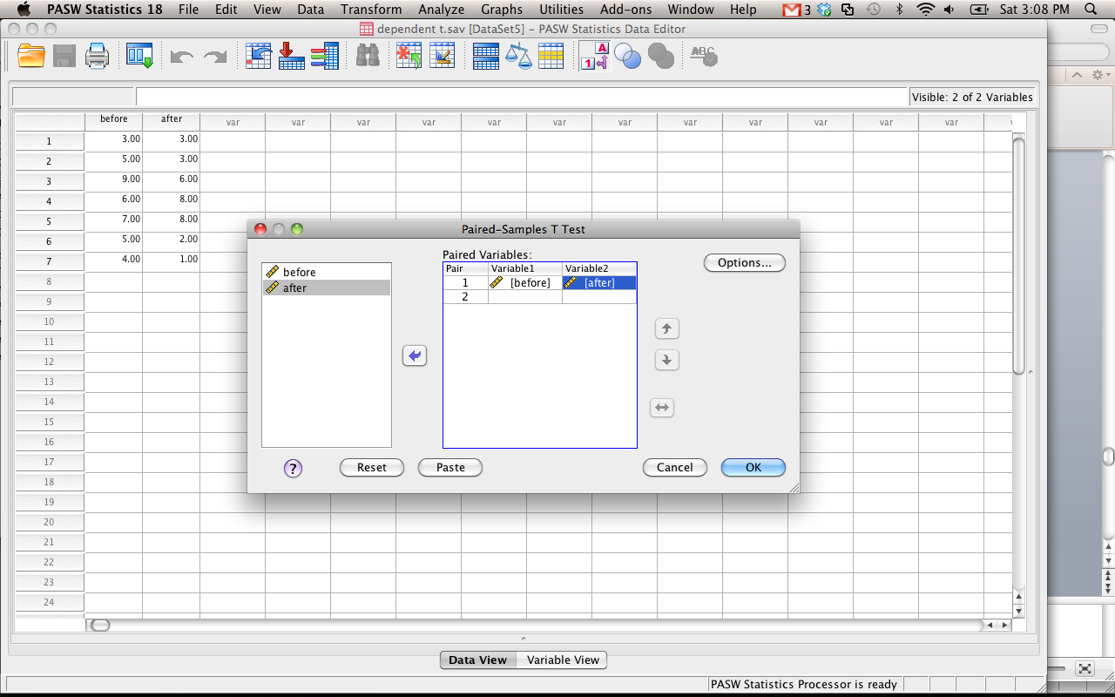

| **Paired Samples Statistics** | | | | | |
| --- | --- | --- | --- | --- | --- |
|  | | Mean | N | Std. Deviation | Std. Error Mean |
| Pair 1 | before | 5.5714 | 7 | 1.98806 | .75142 |
| after | 4.4286 | 7 | 2.87849 | 1.08797 |

| **Paired Samples Correlations** | | | | |
| --- | --- | --- | --- | --- |
|  | | N | Correlation | Sig. |
| Pair 1 | before & after | 7 | .678 | .094 |

| **Paired Samples Test** | | | | | | | | | |
| --- | --- | --- | --- | --- | --- | --- | --- | --- | --- |
|  | | Paired Differences | | | | | t | df | Sig. (2-tailed) |
| Mean | Std. Deviation | Std. Error Mean | 95% Confidence Interval of the Difference | |
| Lower | Upper |
| Pair 1 | before - after | 1.14286 | 2.11570 | .79966 | -.81384 | 3.09955 | 1.429 | 6 | .203 |

* + - 1. First box tells you the means, standard deviations, and standard errors for each time measurement.
      2. The second box tells you the correlation between the two time measurements.
      3. Unless you have a specific question about both of those things, most people just look at box three.
      4. The mean is the mean difference between time measurements.
      5. Standard deviation and standard error of the difference between time measurements.
      6. Confidence interval of the mean difference between time measurements.
      7. T-values, with degrees of freedom and p-value.
      8. How to write: *t*(6) = 1.429, *p* = .203
  1. Independent t-test
     1. Use: Two groups (only two, no more) of completely separate people.
     2. Example: A forensic psychologist conducted a study to examine whether being hypnotized during recall affects how well a witness can remember facts about an event. Eight participants watched a short film of a mock robbery, after which each participant was questioned about what he or she had seen. The four participants in the experimental group were questioned while they were hypnotized and gave 14, 22, 18, and 17 accurate responses. The four participants in the control group gave 20, 25, 24, and 23 accurate responses. Using the .05 significance level, do hypnotized witnesses perform differently than witnesses who are not hypnotized?
     3. Use the independent t-test example.
     4. Analyze > compare means > independent samples t-test.
     5. Move over the “scores”- the thing you measured into the first box.
     6. Move the group labels into the second box (go back and see how to do the value labels).
        1. Hit define groups.
        2. Type in the numbers you used to label the groups (it’s easiest to go with 1 and 2).
        3. Hit continue and ok

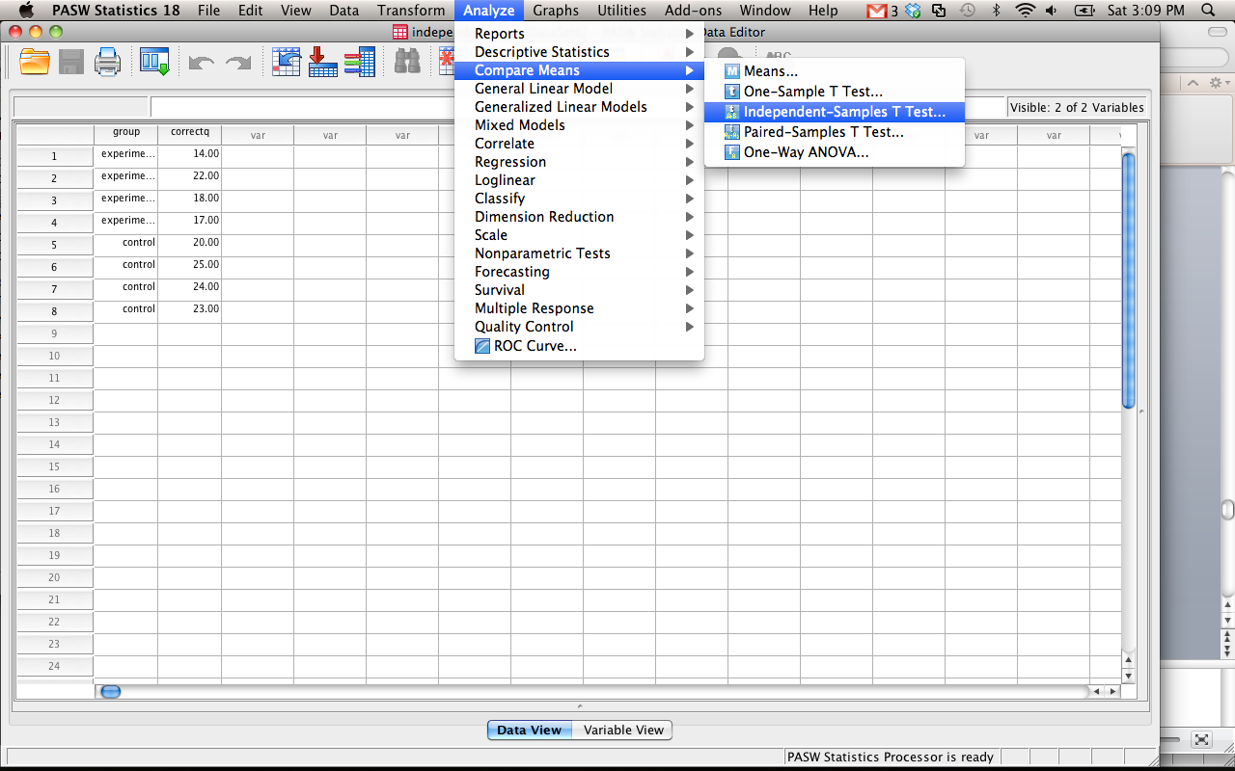

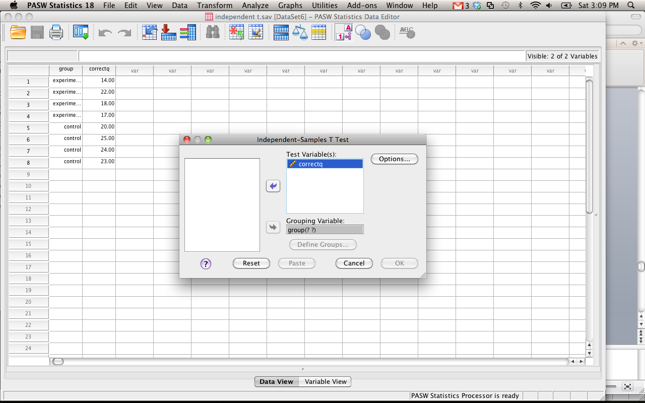

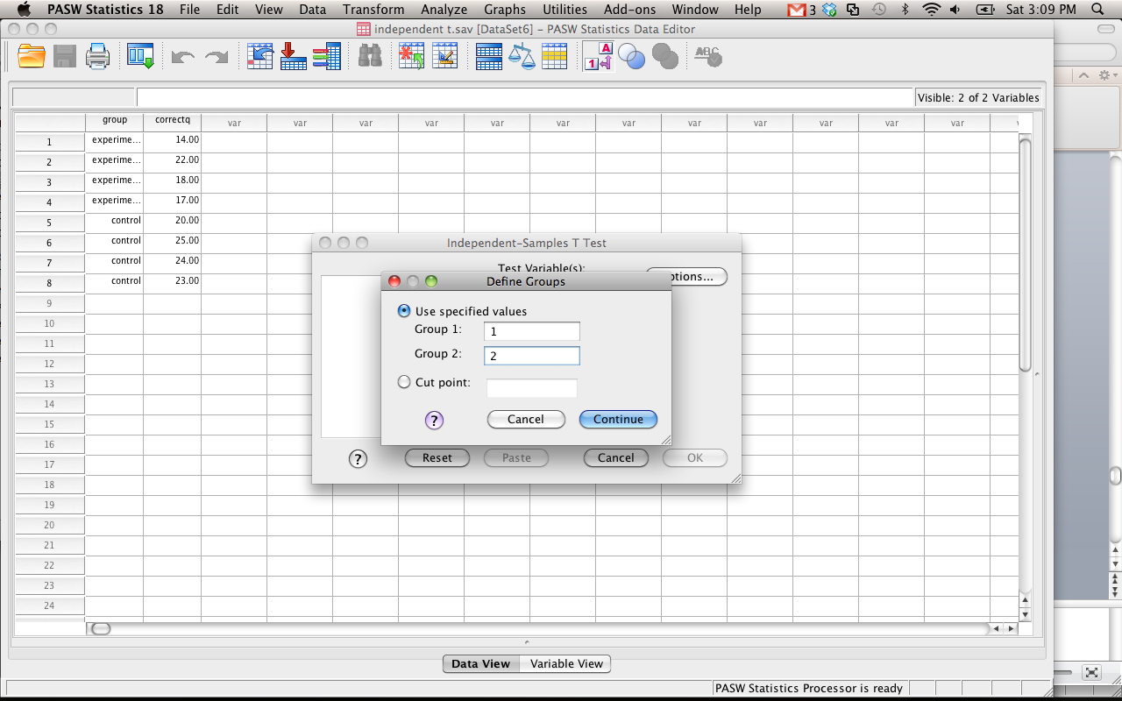

| **Group Statistics** | | | | | |
| --- | --- | --- | --- | --- | --- |
|  | group | N | Mean | Std. Deviation | Std. Error Mean |
| correctq | experimental | 4 | 17.7500 | 3.30404 | 1.65202 |
| control | 4 | 23.0000 | 2.16025 | 1.08012 |

| **Independent Samples Test** | | | | | | | | | | |
| --- | --- | --- | --- | --- | --- | --- | --- | --- | --- | --- |
|  | | Levene's Test for Equality of Variances | | t-test for Equality of Means | | | | | | |
| F | Sig. | t | df | Sig. (2-tailed) | Mean Difference | Std. Error Difference | 95% Confidence Interval of the Difference | |
| Lower | Upper |
| correctq | Equal variances assumed | .386 | .557 | -2.660 | 6 | .038 | -5.25000 | 1.97379 | -10.07968 | -.42032 |
| Equal variances not assumed |  |  | -2.660 | 5.169 | .043 | -5.25000 | 1.97379 | -10.27440 | -.22560 |

* + 1. Output:
       1. The first box contains the means and standard deviations for each group. You will need this information.
       2. Most people use the equal variances assumed line – which will depend on how many people you have and if you tested for it (see data analysis chapter).
       3. The first two sections are Levine’s test for equal variances. You want this to be NOT significant (i.e. p>.05).
       4. T-values, degrees of freedom, and p-values next.
       5. Most people don’t talk about mean differences because that’s more common for a dependent t-test.
       6. Write up: *t*(6) = -2.660, *p* = .038.

1. Correlation (Regression gets its own chapter)
   1. Uses: when you have two variables, but do not know which one *caused* the other one. You should be using at least mildly continuous variables.
   2. Types
      1. Pearson’s r
      2. Spearman’s rho
   3. Assumptions
      1. Normality
      2. Homogeneity
      3. Homoscedasticity – the spread of the errors for the X variable is the same all the way across the Y variable (equal errors)
   4. Example: Scores were measured for femininity and sympathy (see correlation.sav). Is there a correlation between those two variables?
      1. Analyze > Correlate > Bivariate
      2. Move all the variables you want to correlate to the right side and hit ok.

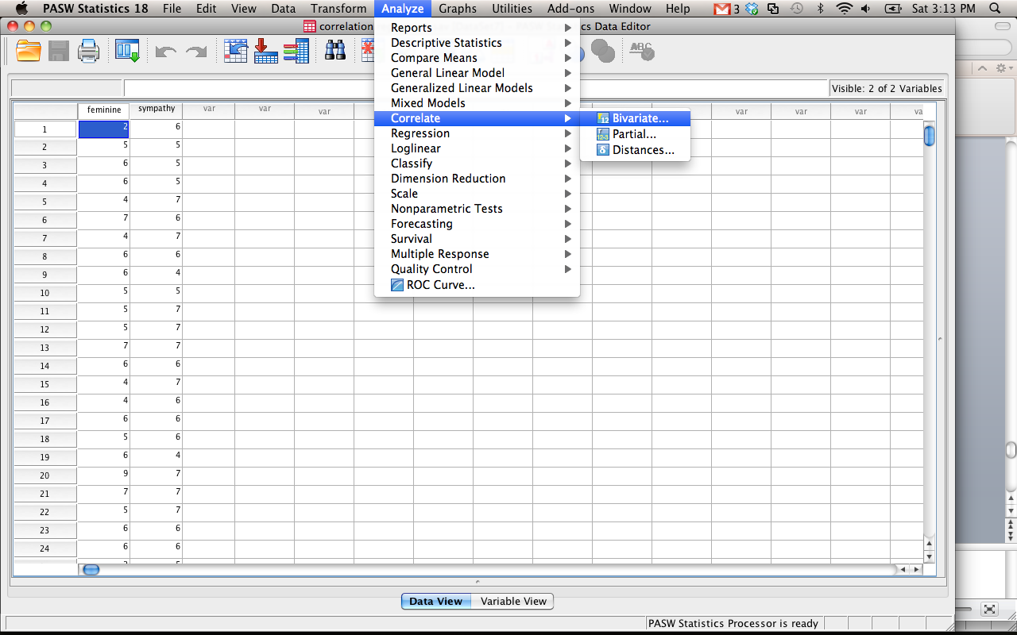

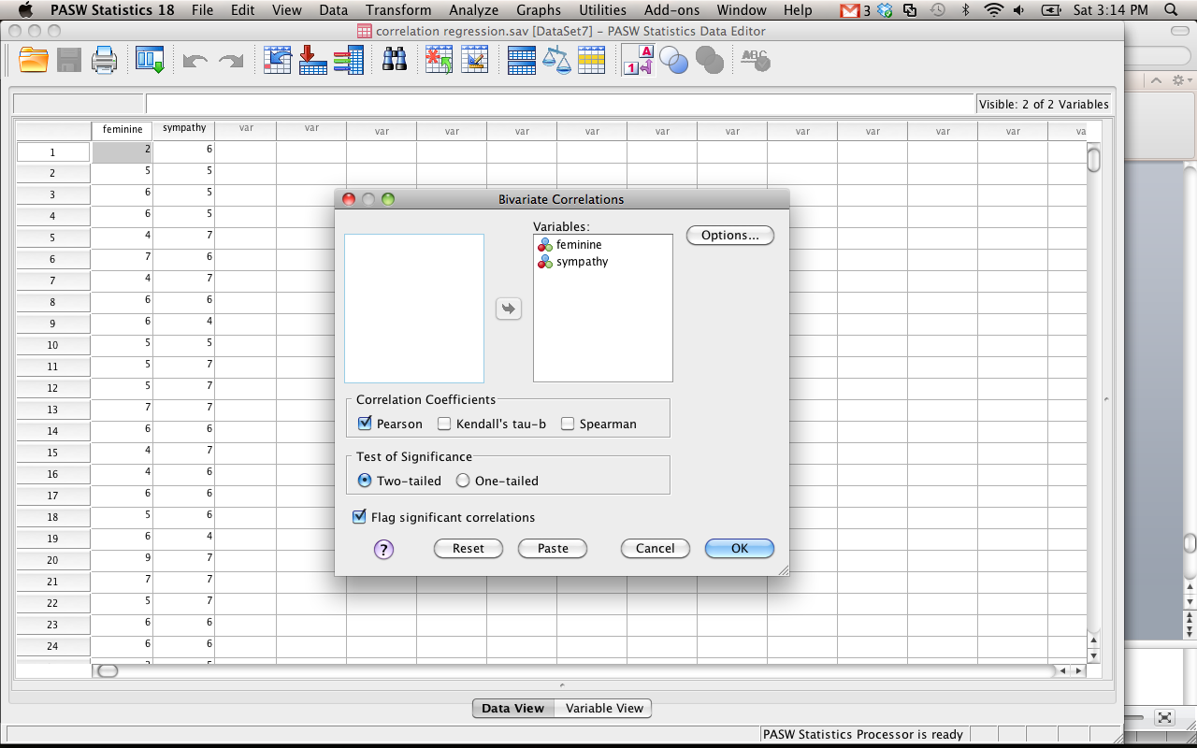

| **Correlations** | | | |
| --- | --- | --- | --- |
|  | | feminine | sympathy |
| feminine | Pearson Correlation | 1 | .183** |
| Sig. (2-tailed) |  | .000 |
| N | 369 | 369 |
| sympathy | Pearson Correlation | .183** | 1 |
| Sig. (2-tailed) | .000 |  |
| N | 369 | 369 |
| **. Correlation is significant at the 0.01 level (2-tailed). | | | |

* + 1. Output: you will get a box of each variable paired with all the other variables. Basically you’ll get each one twice.
    2. Look for the variable combination of X and Y – here it’s .183 – the star means it is significant at p<.05. The second line is the p-value.
    3. Write: *r* = .183, *p* < .001.

1. Chi-Square
   1. Chi-square is a non-parametric test – meaning that you do not need the normal parametric assumptions.
   2. Assumptions:
      1. Each person can only go into one category.
      2. You need enough people in each category (no small frequencies or small expected frequencies).
   3. Uses: when you have nominal (discrete) data and want to understand if the categories are equal in frequency.
   4. Example: The following table shows results of a survey conducted at a particular high school in which students who had a small, average, or large number of friends were asked whether they planned to have children.
   5. 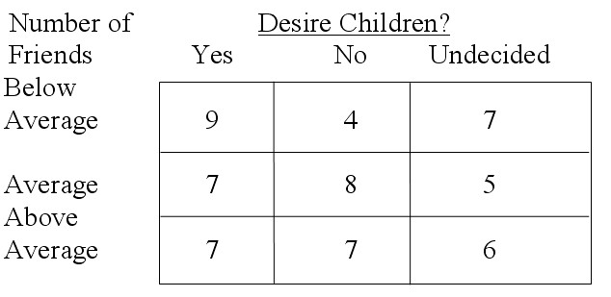
   6. Analyze > nonparametric tests > legacy dialogs > chi-square
      1. Move variables over – note that this analysis will only test one variable at a time and not them together.
   7. OR analyze > descriptive statistics > cross tabs
      1. Move one variable to the rows and one variable to the columns boxes.
      2. Hit statistics > chi-square.

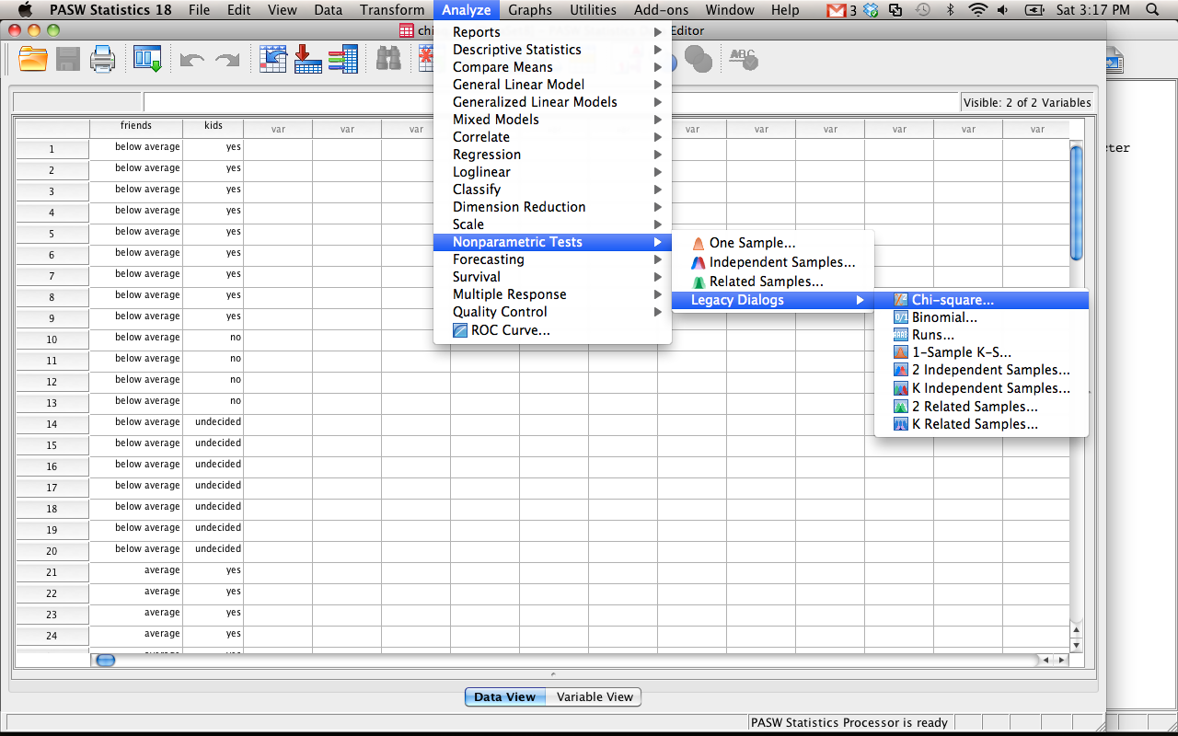

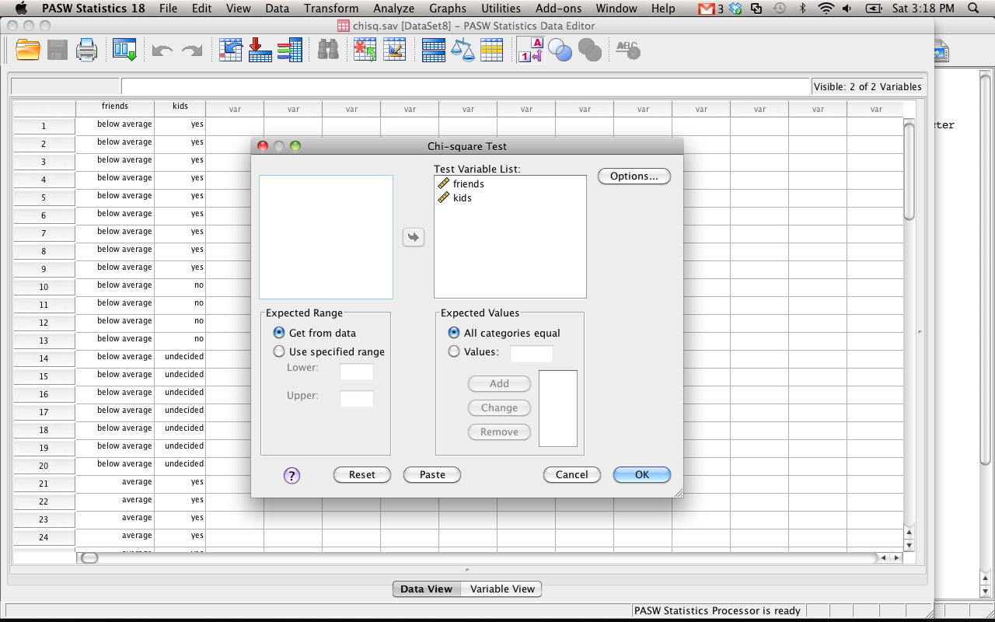

| **friends** | | | |
| --- | --- | --- | --- |
|  | Observed N | Expected N | Residual |
| below average | 20 | 20.0 | .0 |
| average | 20 | 20.0 | .0 |
| above average | 20 | 20.0 | .0 |
| Total | 60 |  |  |

| **kids** | | | |
| --- | --- | --- | --- |
|  | Observed N | Expected N | Residual |
| yes | 23 | 20.0 | 3.0 |
| no | 19 | 20.0 | -1.0 |
| undecided | 18 | 20.0 | -2.0 |
| Total | 60 |  |  |

| **Test Statistics** | | |
| --- | --- | --- |
|  | friends | kids |
| Chi-square | .000a | .700a |
| df | 2 | 2 |
| Asymp. Sig. | 1.000 | .705 |
| a. 0 cells (.0%) have expected frequencies less than 5. The minimum expected cell frequency is 20.0. | | |

* 1. Output for individual chi-square (called goodness of fit)
     1. First two boxes tell you the observed number of people in each box and what they expected to find.
     2. The last box gives you the chi-square value, degrees of freedom and the p-value (asymp sig).
     3. Write: *X*2(2) = .700, *p* = .705

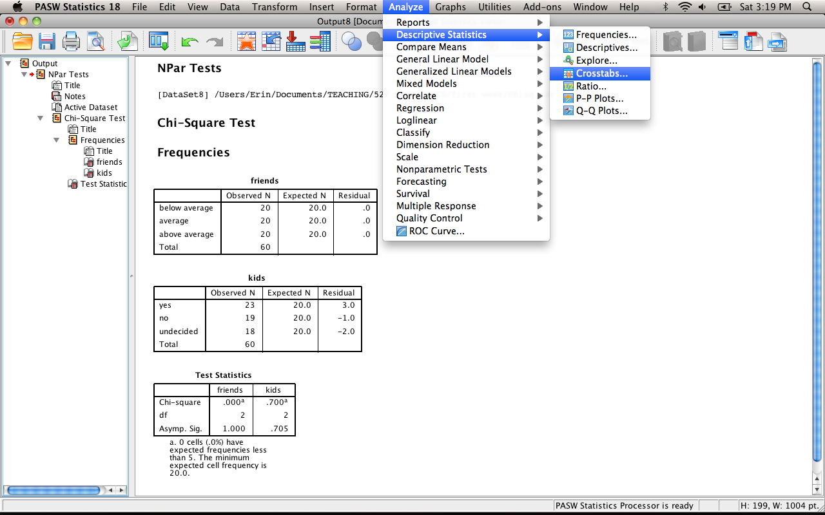

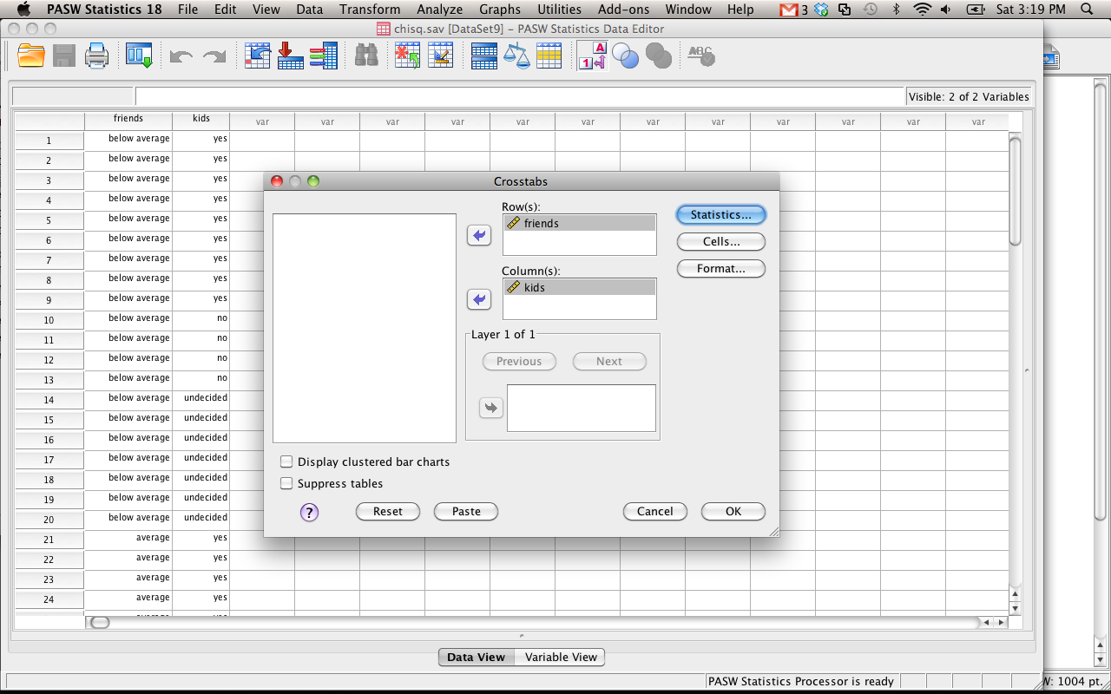

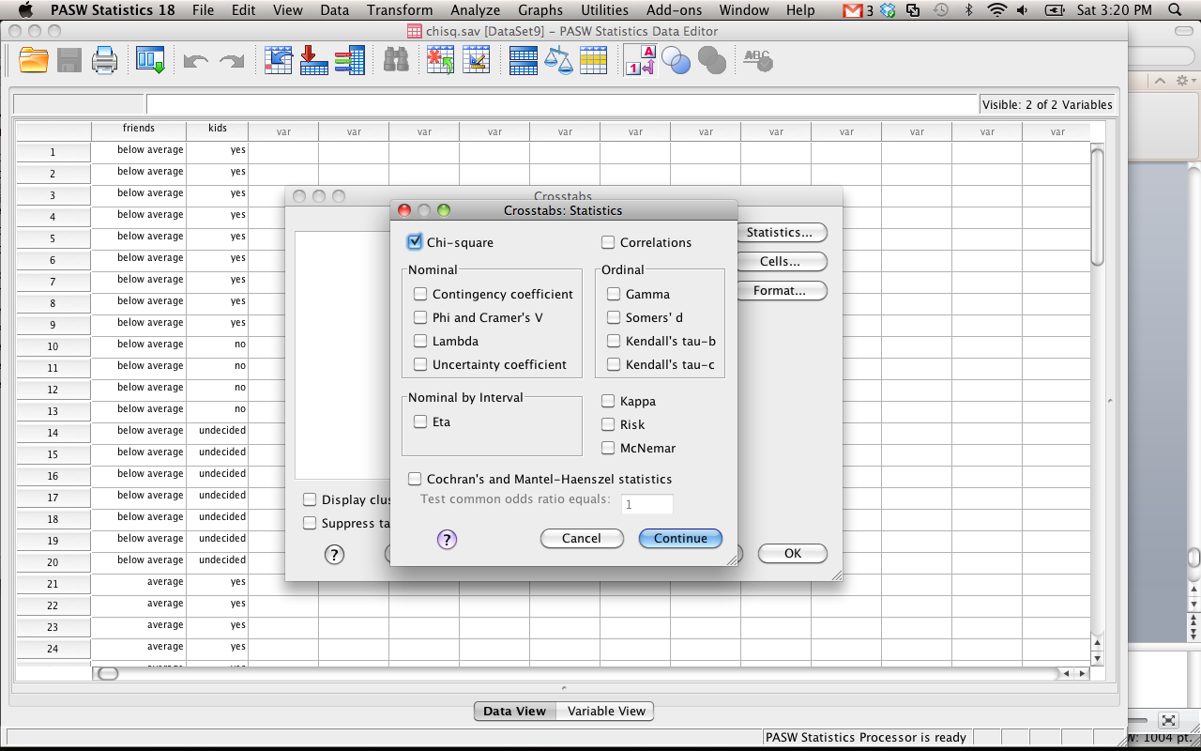

| **Case Processing Summary** | | | | | | |
| --- | --- | --- | --- | --- | --- | --- |
|  | Cases | | | | | |
| Valid | | Missing | | Total | |
| N | Percent | N | Percent | N | Percent |
| friends * kids | 60 | 100.0% | 0 | .0% | 60 | 100.0% |

| **friends * kids Crosstabulation** | | | | | | |
| --- | --- | --- | --- | --- | --- | --- |
|  | | | kids | | | Total |
| yes | no | undecided |
| friends | below average | Count | 9 | 4 | 7 | 20 |
| Expected Count | 7.7 | 6.3 | 6.0 | 20.0 |
| average | Count | 7 | 8 | 5 | 20 |
| Expected Count | 7.7 | 6.3 | 6.0 | 20.0 |
| above average | Count | 7 | 7 | 6 | 20 |
| Expected Count | 7.7 | 6.3 | 6.0 | 20.0 |
| Total | | Count | 23 | 19 | 18 | 60 |
| Expected Count | 23.0 | 19.0 | 18.0 | 60.0 |

| **Chi-Square Tests** | | | |
| --- | --- | --- | --- |
|  | Value | df | Asymp. Sig. (2-sided) |
| Pearson Chi-Square | 2.050a | 4 | .727 |
| Likelihood Ratio | 2.137 | 4 | .711 |
| Linear-by-Linear Association | .036 | 1 | .849 |
| N of Valid Cases | 60 |  |  |
| a. 0 cells (.0%) have expected count less than 5. The minimum expected count is 6.00. | | | |

* 1. Output
     1. You really just want to look at the last book. The first two boxes tell you the frequencies for each box and the expected values for each box.
     2. The last box tells you the chi-square (first line), degrees of freedom, and p-value.
     3. Write: *X*2(4) = 2.05, *p* = .727

# Part 3: APA Style

1. Basic Rules:
   1. 12 point font
   2. Times New Roman
   3. 1 Inch margins
   4. **Double spaced**
2. The physical page:
   1. Centered Results on the first line
   2. No double double space (i.e. don’t hit enter twice)
   3. 2 or 3 decimal places (be consistent)
   4. Statistical abbreviations are *italicized (t F p M SD SE)*
3. The order
   1. Explain variables first, give people a brief warning about what’s going on
   2. Start with Descriptives
      1. Mean = *M*
      2. Standard Deviation = *SD*
      3. Standard Error = *SE*
      4. Most common thing to list is the Mean and Standard Deviation
      5. For each group or variable or those combinations.
      6. If there are a lot of variables, you can make a table or chart
      7. Usually depends on the data…
      8. Do not spell out numbers.
      9. Do not abbreviate variable names (aka it needs to be in English!).
   3. List the test that you performed (ANOVA, t-test, etc.).
      1. Tell if the test was significant or not, but in terms of your question.
         1. The dual task group was not significantly different from the single task group.
         2. The college student average was significantly below the normal average.
      2. In the same sentence you listed the significance of your test, you will list the associated values.
         1. T-tests look like this:
            1. *t*(degrees of freedom) = t-number, *p*= p-value.
            2. *t*(47) = 4.75, *p*=.02
         2. F-tests
            1. *F*(df between, df within) = f number, *p*= p value
            2. *F*(1,35) = 12.35, *p*=.001
         3. Correlation
            1. *r* = correlation, *p* = p-value
            2. *r* = .45, *p*<.001
         4. Chi Square
            1. X2 (degrees of freedom) = chisquare, *p* = pvalue
            2. X2 (35) = 265.50, *p*=.05
         5. Other common ones:
            1. Beta = β
            2. Regression variance = *R*2
4. Graphs and Such

Tables:

Table 1.

*Table Title Goes Here*.

|  |  |  |
| --- | --- | --- |
|  | *M* | *SD* |
| X variable | 10.50 | 2.50 |
| X variable | 11.45 | 1.85 |
| X variable | 9.09 | 3.02 |

*Note.* Some important information here.

Line Graphs

Scatter Plots

Bar Graphs